Letter No. 0210-2023-APMTC/CL

Callao, April 28th, 2023

WALLENIUS WILHELMSEN
Edificio Corporativo 253
Entre pasaje 11 y 12, Calle Circunvalación
San Salvador
Colonia San Benito, El Salvador

Attention : Alejandra Romero
Claims Adjuster
Subject : Resolution No. 01
Case file : APMTC/CL/0084-2023
Reference : TOSCANA // US-RB132-TOC-094424
APM TERMINALS CALLAO S.A., (“APMTC”) with Taxpayer Registration No. 20543083888, with registered office at Av. Contralmirante Raygada No. 111, Callao, by virtue of the fact that WALLENIUS WILHELMSEN (“WALLENIUS” or the “Claimant”) has filed its claim the term established in article 2.3, you have not complied with submitting the requirements established in article 2.4 of the APMTC User Claims Attention and Solution Regulation (the “Regulation”), we proceed to state the following:

- BACKGROUND

- On April 17th, 2023, WALLENIUS filed a claim via email to the APMTC Claims Department, for the alleged damage to the unit identified with VIN CAT0834KHL4Y00258 of the vessel TOSCANA during transshipment operations on February 22nd, 2022.

- On April 21st, 2023, APMTC issued the letter No. 0189-2023-APMTC/CL, stating that the Claimant must comply the following documents according to the APMTC Claims Handling Rules, otherwise its claim will not be filed.

- Details of the Legal Representative, the Attorney and the sponsoring attorney, if any.
- Simple copy of the document that proves the legal representation (eg validity of powers of the legal representative, the attorney or the lawyer if any).
- Simple copy of the identity document (ID, Passport or Alien Card).
- Signature or fingerprint of the User who presents the claim or of his Legal Representative.
- The factual and legal grounds that support the claim.

- ANALYSIS

From the review of the facts of the claim, we point out that, in application of article 2.7 of the Regulation of Attention and Solution of Claims of APMTC, the claim submitted by WALLENIUS cannot be attended because the claimant did not comply to present all the documents required in our communication letter No. 01089-2023-APMTC / CL (Annex 01), corresponding to file APMTC/CL/0084-2023, within the established period of 02 business days in accordance with the provisions of the regulatory standards of the APMTC Claims Regulations.

- RESOLUTION

Due to the foregoing, the claim request submitted by WALLENIUS for the file APMTC / CL / 0084-2023 is declared INADMISSIBLE.

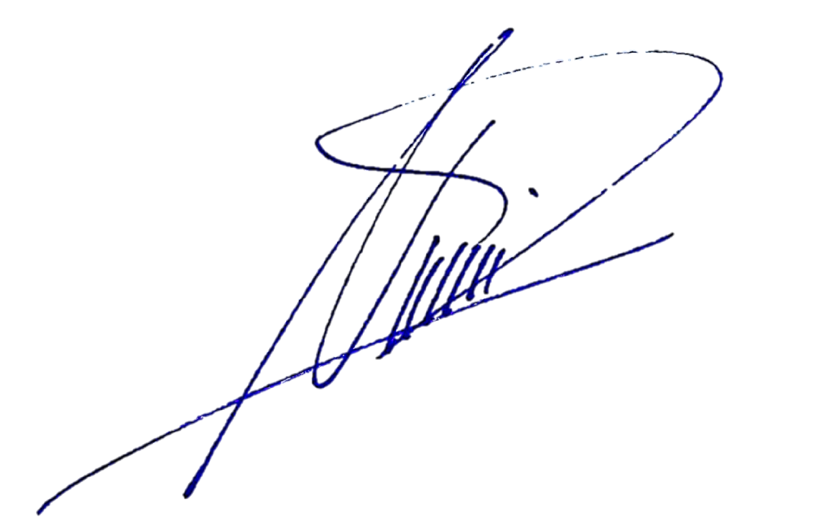

Deepak Nandwani
Customer Experience Manager
APM Terminals Callao S.A.

